Assignment 4 - Emily Hao

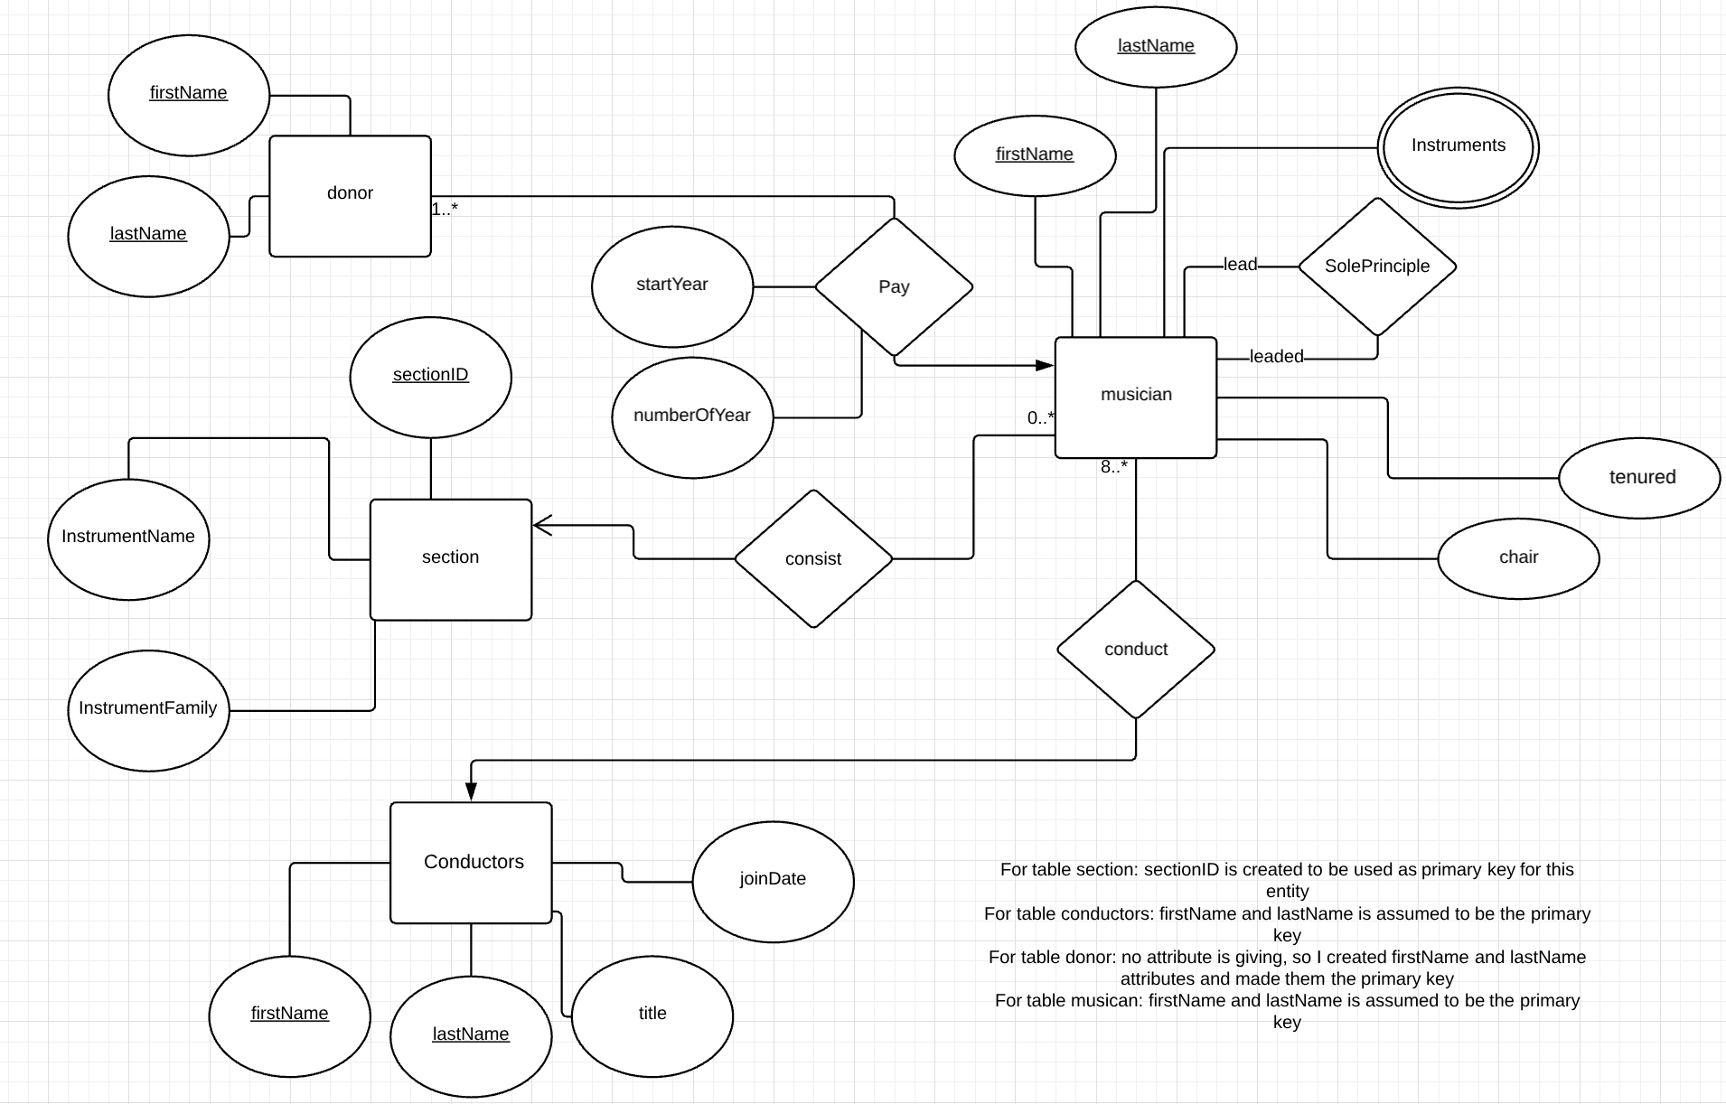

note: sectionID from section entity is created and assigned to be the primary key only to prevent the possibilities of duplicates of instrumentName and instrumentFamily appear in the entity

2a. 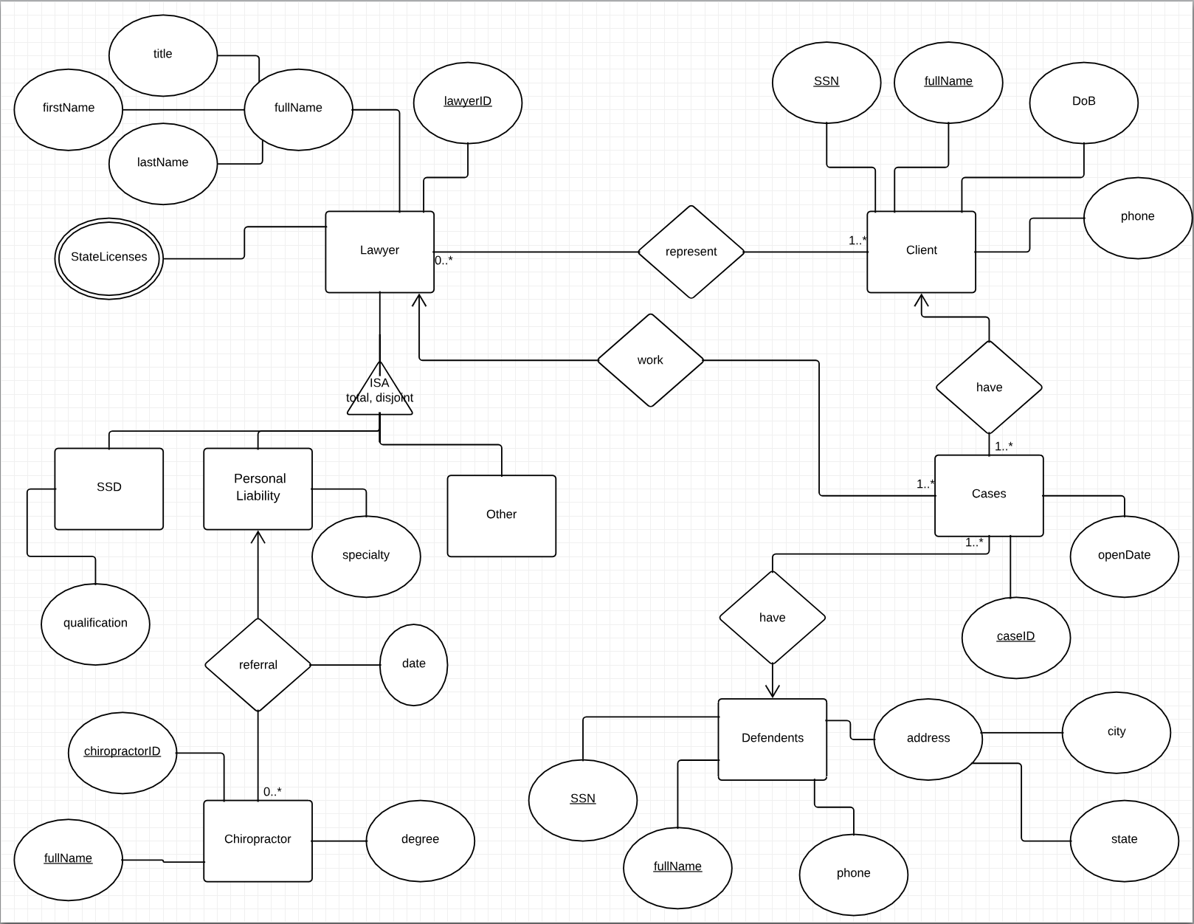

note: Assumed that each primary key for each entity was unique across the entire relation.

Note that lawyerID is the primary key for Lawyer, SSD, Personal Liability, Other.

Note that fullName and SSN are assumed to be the primary key for Client, Defendants, chiropactorID and fullName are assumed to be the primary key for Chiropractor.

2b. 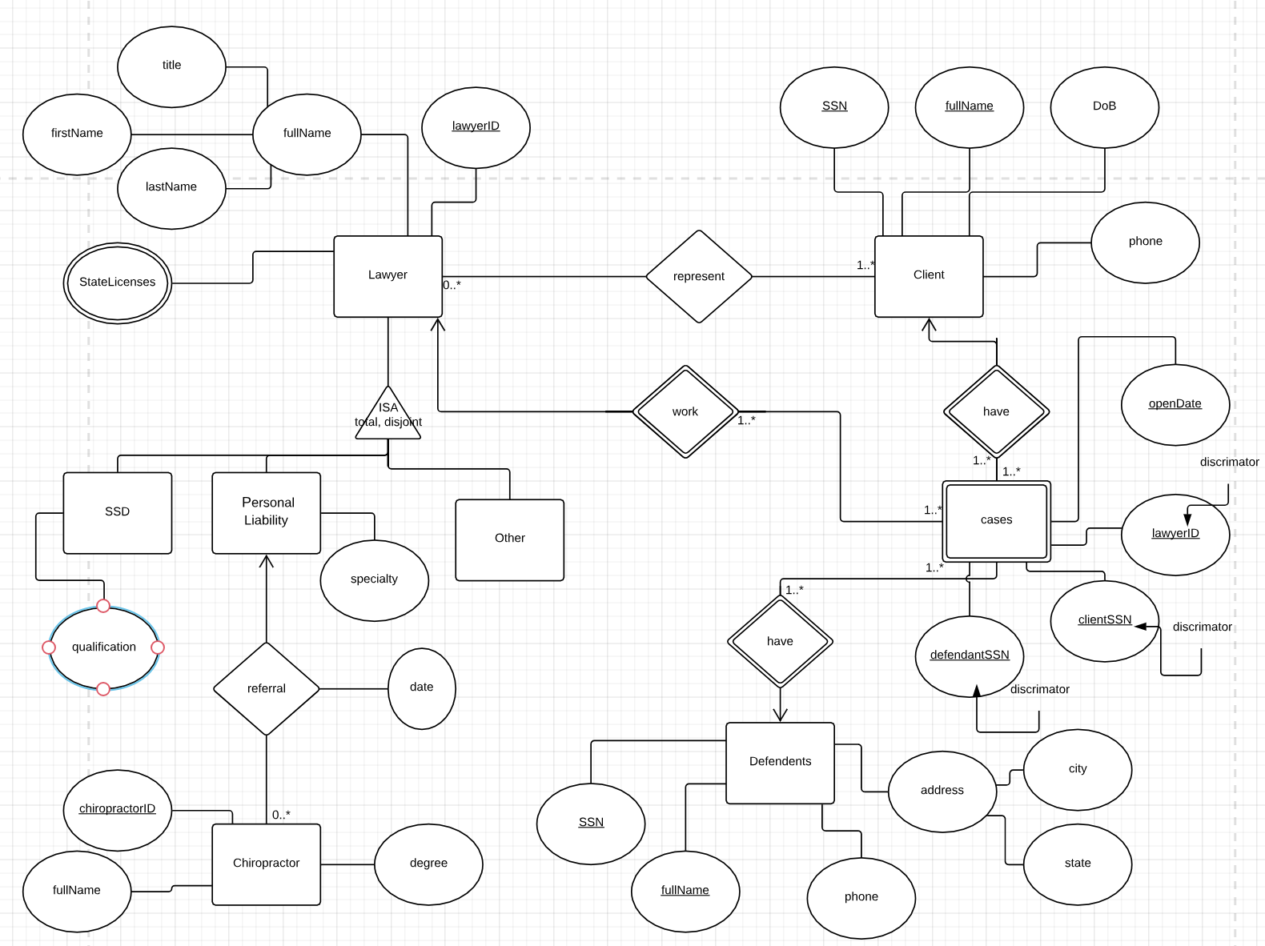

Note: It is assumed that the primary key for each entity is unique across the entire relation.

For the entity Cases, the combination of the attributes lawyerID, defendentsSSN, clientSSN and openDate is used to identify the legal cases, note that lawyerID, clientSSN, and defendantsSSN are discriminator.